Ques1: Create a program for developing a window of green color.

Source Code

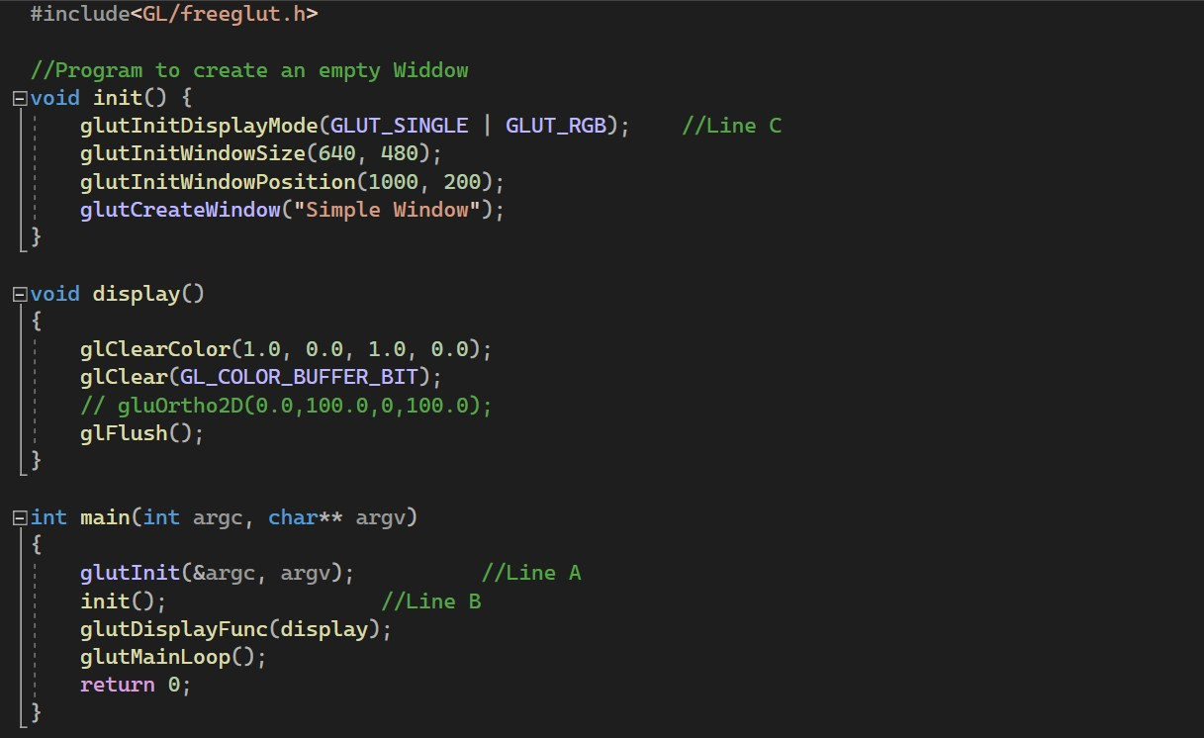

Output

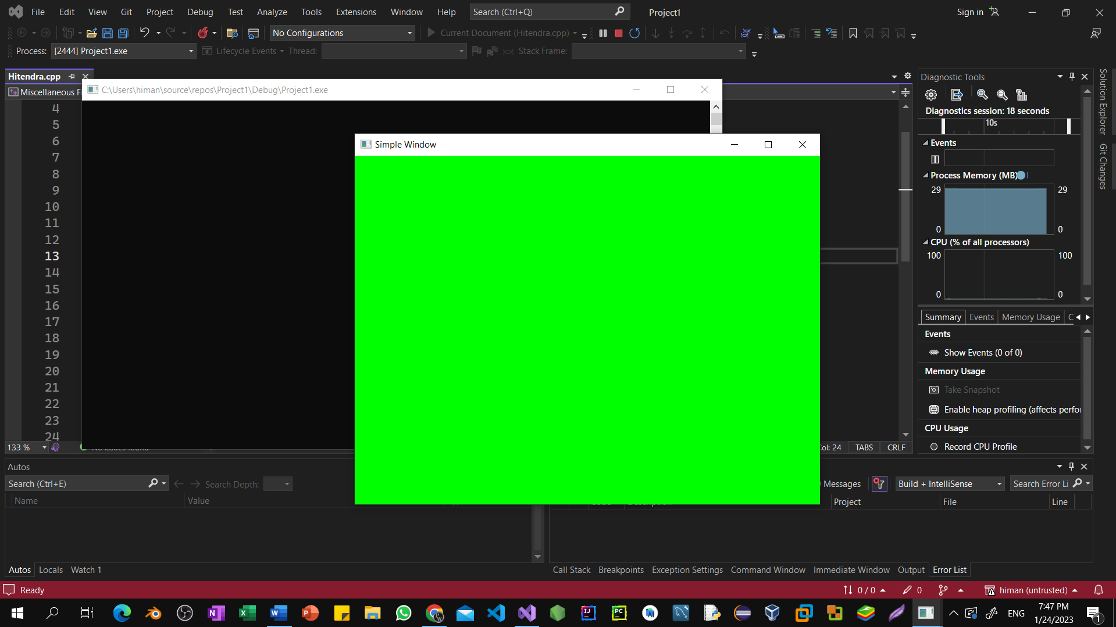

Ques2: Create a program to draw primitive shapes (triangle, rectangle, circle and square).

Source Code